**Ministry of Communications and Information Technology  
Digital Egypt Pioneers Initiative) DEPI)**

**Graduation Project Document**

**Analyzing Key Drivers of the American Stock Market**

**2013 -2018**

Supervisor:   
**ENG/ Marwan Mokhtar**

**October 2024**

**Team Members:**

* Maha Fathy Ghoneim
* Gehad Abdulhamied Soliman
* Dina Khaled Helal
* Ayat Abdulhamied Abulkhair

**Abstract:**

This project explores and analyzes S&P 500 ,stock market trends and factors that influence trading activity within the American stock market. The analysis uses six Excel datasets that cover a wide range of data, including stock prices, trading volumes, financial metrics, and industries performance. The primary goal of the project is to uncover patterns and insights that can inform better decision-making for investors and analysts.

The datasets provide detailed information about stock performance, industries analysis, and financial indicators for companies listed on the market. Analytical SQL queries are employed to process and extract meaningful insights from the data, while Power BI is used to create visualizations that help highlight key trends, such as sector performance, price volatility, and trading volumes. These visualizations enable stakeholders to understand the dynamics of the stock market in a clearer and more intuitive way.

Through the analysis, the project identifies that sectors like technology and healthcare lead in trading activity, while stocks in sectors such as energy exhibit higher price volatility, indicating a higher risk for investors. Overall, the findings from this project contribute valuable insights into the workings of the American stock market, providing practical information for financial analysts and investors looking to optimize their investment strategies.

**Introduction**

* **Background**:

The stock market is a vital component of the global economy, reflecting investor sentiment and financial stability. Understanding the drivers behind stock performance, such as trading volume, price fluctuations, and sector trends, is essential for both individual and institutional investors.

* **Objective**:

The goal of this project is to explore stock market data, focusing on trading patterns, sector-based performance, and stock price fluctuations, to uncover actionable insights that can aid in financial decision-making.

**Data Collection**

The data used in this project was sourced from various reputable platforms, including **Yahoo Finance**, **Wikipedia**, **Kaggle**, and additional **EXCEL** files provided. Each source provided different types of data that were crucial for conducting a comprehensive analysis of the American stock market.

* **Yahoo Finance**: We get the data from yahoo finance by using a python code

* **Wikipedia**[: https://en.wikipedia.org/wiki/List_of_S%26P_500_companies](https://en.wikipedia.org/wiki/List_of_S%26P_500_companies)

Data regarding company-specific information, such as sector classifications and business descriptions, was gathered from Wikipedia. This allowed for an analysis of stock performance at the sector level, providing insights into how different industries perform in the market.

* **Kaggle**: <https://www.kaggle.com/camnugent/sandp500>

Kaggle datasets were used to obtain additional financial and operational data, such as revenue, profit, and other key metrics. Kaggle hosts a wide range of publicly available datasets, which are useful for in-depth financial and business analysis.

* **EXCEL Files**: Additional EXCEL files were used to complement the data from the mentioned sources. These files contained preprocessed data specifically tailored for the project’s needs, including date dimension tables, GIO Fact, SP500 historical data, and financial fact data.

**Data Overview**

* + **Stock Fact**: Contains data on stock prices, volume, and trading dates.
  + **Security**: Contains information on the companies (e.g., sector, industry).
  + **Fact Financial**: Includes financial performance metrics like revenue and profit.
  + **SP500 Historical Data**: Provides historical stock performance data for the S&P 500.
  + **GIO-Fact**: Offers additional financial and operational metrics.
  + **Date Dim**: Contains date information for time-based analysis.

**Overview on each Table:**

1. **Fact Stock**

**2-Security**

The provided data appears to be stock market data for a specific stock symbol ("AAL" in this case), capturing daily trading details.

**Symbol:** The stock ticker symbol representing the company (AAL in this case, likely for American Airlines).

**Stock_Date :** The date for each trading session, formatted as DD-MM-YY, indicating when the stock's performance was recorded.

**Open :** The stock’s opening price at the start of the trading day.

**High :** The highest price reached by the stock during the trading day.

**Low :** The lowest price recorded for the stock during the trading day

**Close :** The stock’s price at the end of the trading day.

**Volume :** The number of shares traded during the trading day.

This dataset provides a time series of stock trading data, useful for analyzing trends in the stock's performance over time. It could be used to monitor price fluctuations, trading volume, and patterns in the stock’s daily movement.

**Symbol :** The stock ticker symbol that uniquely identifies a company in the stock market.

**Security :** The full name of the company.

**GICS Sector :** The sector of the Global Industry Classification Standard (GICS) to which the company belongs. This classification helps in sector analysis and comparison.

**GICS Sub-Industry :** A more specific classification under the GICS sector, providing detailed insights into the company’s business operations.

**City :** The city where the company is headquartered.

**State :**The state of the company's headquarters.

**Date Added :** The date when the company was added to the dataset, indicating its inclusion in the stock market.

**CIK :** The Central Index Key, a unique identifier assigned by the SEC to corporations for tracking their filings.

**Founded :** The year the company was established, which can be useful for historical analysis.

**3- Fact Financial**

This data that contains key financial metrics for various companies (identified by their stock symbols).

**Symbol :** The stock ticker symbol representing each company.

**Price :** The current stock price of the company.

**Dividend_Yield :** The dividend yield, which shows how much a company pays out in dividends each year as a percentage of its stock price.

**Earnings_Share :** The earnings per share (EPS) metric, indicating the portion of a company’s profit allocated to each outstanding share.

**Week_High_52 :** The highest stock price over the past 52 weeks (1 year).

**Week_Low_52 :** The lowest stock price over the past 52 weeks.

**Market_Cap :** The total market capitalization of the company, which represents the total dollar market value of a company's outstanding shares.

**EBITDA :** Earnings before interest, taxes, depreciation, and amortization—a measure of a company’s overall financial performance.

**Price_Sales :** The price-to-sales ratio, which compares the company’s stock price to its revenue.

**Price_Book** **:** The price-to-book ratio, which compares the company’s stock price to its book value.

This table is likely used for financial analysis and can help assess the performance, valuation, and profitability of different companies.

**4- S&P500 Historical Data**

**Date :** The date for which the stock market data is recorded.

**Open :** The price at which the stock opened on that particular day.

**High :** The highest price reached by the stock during the trading session.

**Low :** The lowest price recorded for the stock during the trading session.

**Close :** The price at which the stock closed at the end of the trading day.

**Volume :** The total number of shares traded during the day, indicating the stock's liquidity and trading activity.

**5-GIO-Fact**:

Global Indicator Fact Table tracks daily values of key economic indicators.

**GIO_Date:** The date on which the data for the various indicators was recorded.

**Gold_Price :** The price of gold on the corresponding date (likely measured in USD per ounce).

**Oil_Price :** The price of oil on the corresponding date (likely measured in USD per barrel).

**Interest_Rate :** The interest rate on the corresponding date (possibly a benchmark rate like the federal funds rate or another reference rate).

This table can be useful for performing time series analysis on economic and financial data, such as analyzing trends in commodity prices (gold and oil) or tracking how changes in interest rates correlate with other economic factors.

**6-Date Dim**

**Date :** The date for which the stock market data is recorded.

**Open :** The price at which the stock opened on that particular day.

**High :** The highest price reached by the stock during the trading session.

**Low :** The lowest price recorded for the stock during the trading session.

**Close :** The price at which the stock closed at the end of the trading day.

**Volume :** The total number of shares traded during the day, indicating the stock's liquidity and trading activity.

**Excel** (for data cleaning)

Data cleaning is an essential step to ensure that the dataset is accurate, consistent, and ready for analysis. Excel was used to clean and prepare the American stock market data. The cleaning process included removing duplicates, handling missing values, correcting data types, and ensuring uniform formatting across the dataset.

**Cleaning Steps**

1. Checking and Correcting Data Types

2. Null Checks (Handling Missing Values)

3. Outliers Detection and Treatment

4. Splitting Columns by Comma (Date Formatting)

5. Ensuring Data Accuracy

**Analytical SQL (PostgreSQL)**

PostgreSQL was used as the primary tool for executing analytical SQL queries on the datasets. Analytical SQL played a critical role in extracting meaningful insights from the stock market data, enabling deep exploration of stock price movements, trading volumes, sector-based performance, and financial metrics.  
  
We convert the EXCEL files to CSV files because postgre doesn’t go with the EXCEL files

**Tables Creation:**

**1- Stock Fact:**

**5-GIO-Fact**:

**6- Date Dim**:

**Quires and Run:**

1-What are the top five closing prices by sector for each year , along with their corresponding symbols and sectors ?

The SQL query retrieves the top five closing prices of stocks, categorized by sector and year, alongside their corresponding stock symbols. The results are formatted to two decimal places for readability.

1. **What is the correlation between Gold Price and Oil Price?**

The SQL query calculates the correlation coefficient between gold prices and oil prices using data from the GIO_fact table. The correlation coefficient quantifies the degree to which the two variables move in relation to each other, providing insights into their historical relationship.

This mean that if the Gold price increases the Oil price will also increase.

1. **A computer code with text

   Description automatically generated with medium confidenceWhich ten securities have the highest net profit based on outstanding shares**?

The SQL query retrieves and calculates key financial metrics for stocks from the financial_fact and security tables, specifically focusing on outstanding shares and net profit. The query is designed to identify the top 10 stocks based on their net profit, providing valuable insights for investors and analysts.

**4-How does the average trading volume correlate with the average price of GOOGLE by year?**

This query is designed to analyze the relationship between the average trading volume and the average price of the stock symbol 'GOOGL' on a yearly basis. This analysis helps in understanding how trading activity correlates with price movements for the stock over time.

Here we got that if the price increase the volume decrease and we find that there is an exception in2018   
In **October 2018**, **Google** revealed a data breach in **Google+** that affected 500,000 users. This led to a loss of trust and the eventual shutdown of the platform. Although this was negative news, it increased stock trading volume as investors saw it as a short-term buying opportunity.

This problem start in 2015 but google publish it in 2018

Another event in **2018** was the controversy surrounding **Project Maven**, where Google’s collaboration with the U.S. military for AI drone technology sparked employee protests. Google decided not to renew the contract, impacting its reputation and stock trading activity.

Despite the negative impact, these events resulted in increased volatility and trading volume as investors reacted to these major developments.

**5-What is the distribution of companies by market capitalization size?**

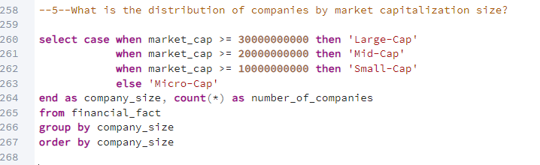 This query analyze the distribution of companies based on their market capitalization size. This categorization helps stakeholders understand the composition of the market and the number of companies within various capitalization ranges.

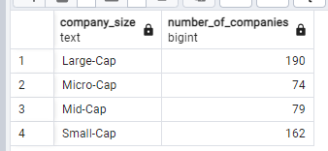

**6-Which companies are considered undervalued based on their Price-to-Earnings ratio?**

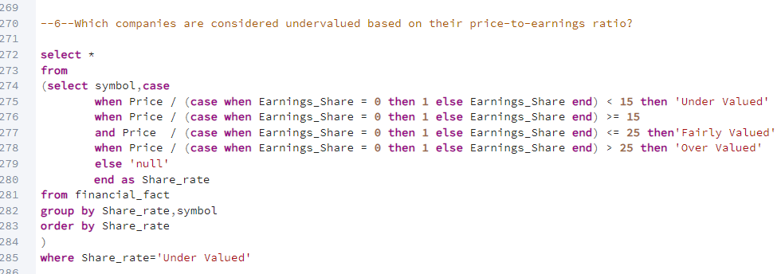

This query identify companies that are considered undervalued based on their price-to-earnings (P/E) ratio. This analysis helps investors and analysts determine which stocks might represent attractive buying opportunities.

**7-What is the count of companies in each category?**

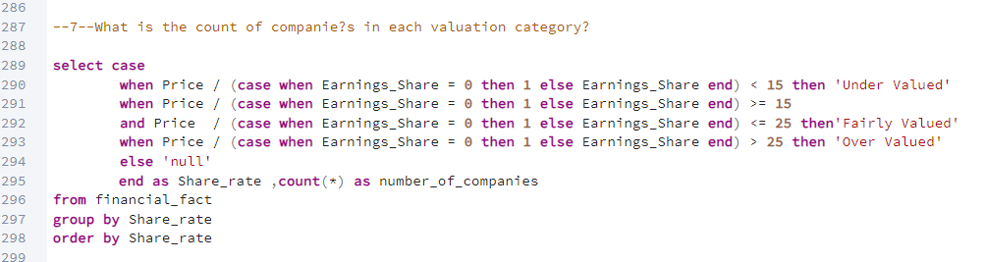

This query counts the number of companies in each valuation category based on their price-to-earnings (P/E) ratio. This analysis provides insights into how many companies fall into each valuation bracket, helping investors assess market conditions.

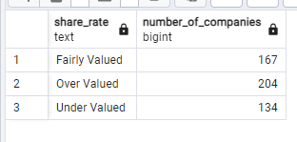

**8-Which industry had the highest average trading volume for each year?**

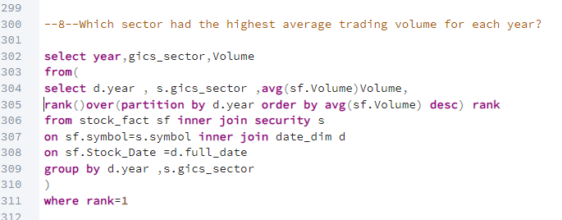

This query identify the sector which have the highest volume in each year

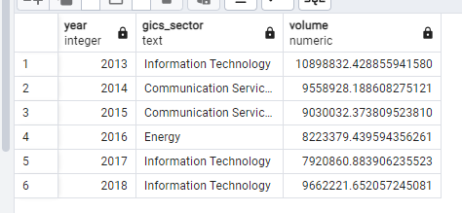

**9-What is the total trading volume on S&P 500 index for each year?**

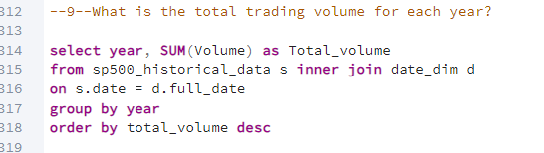

This SQL query calculates the total trading volume of stocks for each year within the dataset. By joining the sp500_historical_data table with the date_dim table on the date field, the query aggregates the trading volume data. The SUM(Volume) function is utilized to compute the total volume for each year, and the results are grouped by year. The final output is ordered in descending order of total volume, allowing for easy identification of the years with the highest trading activity.

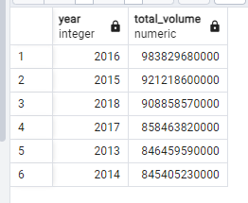

- OPEC's production decisions led to volatility in oil prices. This volatility often translated into increased trading activity in the S&P 500 as investors adjusted their portfolios in response to changing economic sentiments.

**10-Which days experienced significant closing price changes greater than 2%?**

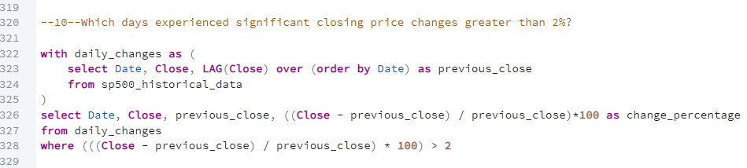

This SQL query identifies days in the stock market where the closing price experienced significant changes, specifically those exceeding 2%.

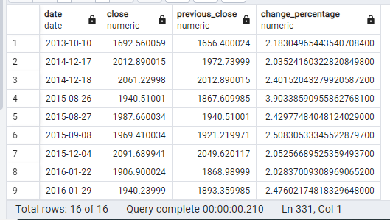

On October 10, 2013, the S&P 500 index rose due to growing optimism about reaching an agreement in the U.S. Congress to resolve the government debt ceiling crisis. At the time, the U.S. government was on the verge of defaulting on its debt due to political disagreements over raising the debt ceiling, which caused concern in the markets. As signs of a potential resolution emerged, investor confidence improved, and stock markets, including the S&P 500, rose.

**11-What is the best performing month in every year based on volume?**

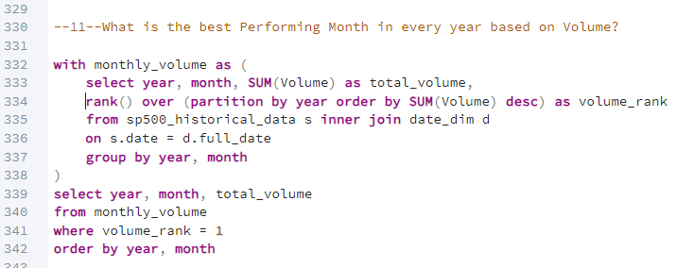

This SQL query aims to identify the best-performing month for trading volume within each year based on historical stock data from the S&P 500

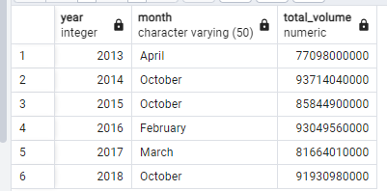

Here we can catch that the highest volume month in the year usually can be October because it is the beginning of the financial year and more people increase their investments in the stock market .

**12-What is the lowest performing quarter in every year based on volume**

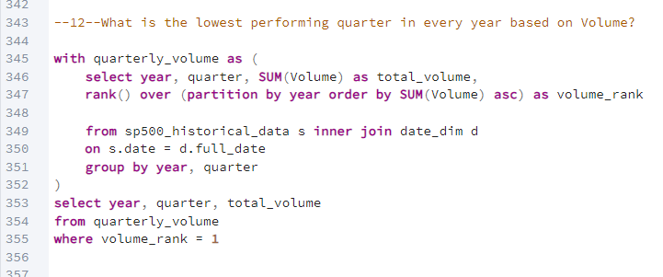

This SQL query identifies the lowest performing quarter for each year based on trading volume in the S&P 500 historical data.

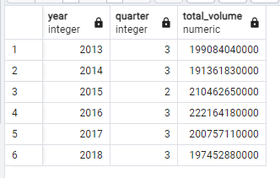

-Here we can catch that the third quarter often be the lowest quarter in volume because it is the end of the financial year so investors decrease the investments in this time and also US Presidential Election often start to be prepared in September and this causes some political problems  
-Decline after the ex-dividend date: After dividends are distributed, the stock price typically decreases by the amount of the dividend. Investors who purchased the stock solely to benefit from the dividend may sell after receiving it, which reduces trading volume or leads to temporary fluctuations.

**Power BI**

Power BI was utilized to visualize key insights derived from the data, allowed us to create interactive dashboards that offer a dynamic view of the American stock market data. This enabled stakeholders to quickly understand trends, patterns, and important metrics such as stock prices, trading volume, volatility, and more.

**Calculate Columns:**

In this section, we explain the calculated columns created during the data cleaning and analysis process. These columns provided additional insights and metrics that were essential for understanding trends and making data-driven decisions in the American stock market analysis.

**-Average Index Price**

This calculated column is designed to provide the **average price** of the S&P 500 index on a given day by taking the sum of the **opening price** and the **closing price**, then dividing by 2.

**-Average Share Price**



Similar to the Average Index Price, this calculated column calculates the **average daily share price** for individual stocks by averaging the opening and closing prices.

**-Company Size**

This calculated column classifies companies based on their market capitalization into different categories such as Large-Cap, Mid-Cap, Small-Cap, and Micro-Cap. It uses the SWITCH() function to categorize the companies into size buckets based on their market cap. Company Size

**-Daily Change( for index)**

This calculates the **daily price change** by comparing the closing price on one day to the opening price on the following day. If the closing price of the current day is equal to the next day’s opening price, it returns 0 (no change), otherwise, it returns 1.

**-Net Profit (share)**

This calculated column computes the company's **Net Profit** by multiplying the **Earnings per Share (EPS)** by the **Outstanding Shares**. This shows the total profit generated by the company, based on the shares currently held by all shareholders.

**-Outstanding Shares**



This column calculates the **Outstanding Shares** of a company by dividing the **market capitalization** by the **stock price**. The DIVIDE function ensures that division by zero is handled gracefully by returning 0 if the price is missing.

**- Oil to Gold Ratio**

This calculated column computes the **Oil to Gold Ratio** by dividing the price of gold by the price of oil. This ratio is used to measure the relative value of these two commodities.

**- P/E Category**

This calculated column categorizes stocks based on their **P/E (Price-to-Earnings) Ratio**. If the ratio is below 15, the stock is considered **Under Valued**, between 15 and 25 it is **Fairly Valued**, and above 25 it is **Over Valued**. This classification helps in assessing how the market values the stock relative to its earnings.

**-Price Performance Each Simple**

This column calculates the **Price Performance** of a stock relative to its **52-week high and low**. It measures where the current stock price stands between the highest and lowest price in the last 52 weeks, giving a simple performance indicator.

**Measures**

**- Annual change close percentage**

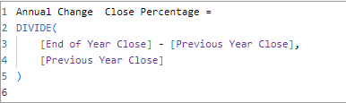

This DAX formula calculates the **annual percentage change** of the closing price by subtracting the previous year's closing price from the end of the current year's closing price, then dividing by the previous year's close. This gives you the percentage change year-over-year.

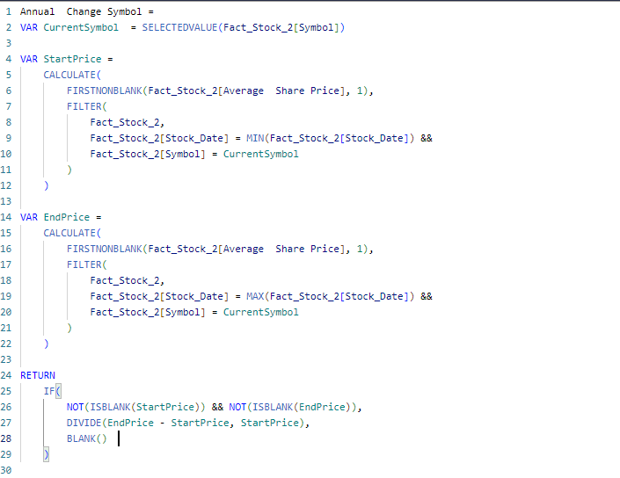**-Annual change symbol**

This formula calculates the annual percentage change for each stock symbol. It retrieves the first (starting) and last (ending) share prices for a specific symbol and computes the percentage change.

**-Annual Gold Change**

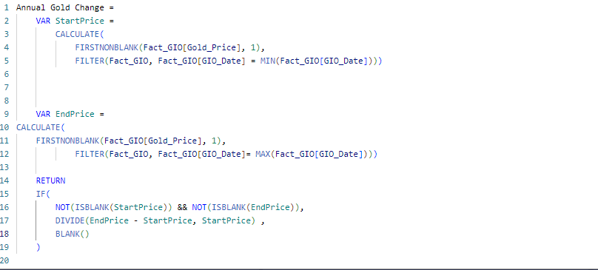

This formula calculates the annual percentage change for gold prices by comparing the starting and ending gold prices over a specific period.

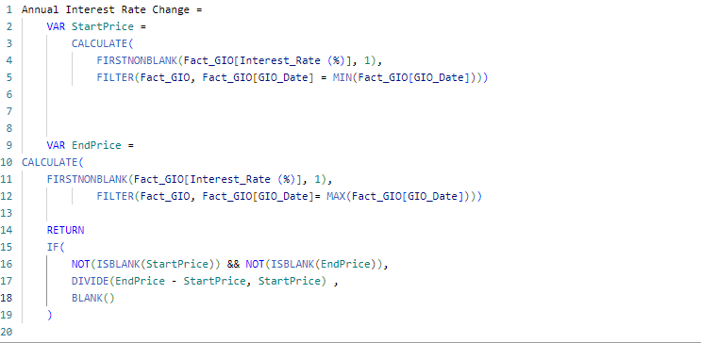**-Annual Interest Rate Change**

This formula calculates the annual change in interest rates by comparing the start and end values of interest rates over a specified time period.

**-Annual Oil Price Change**

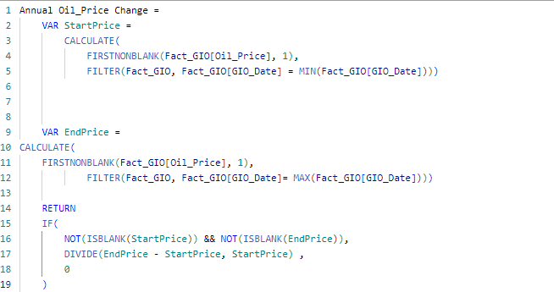

This formula calculates the annual percentage change in oil prices by comparing the start and end prices of oil within a given year.

**-Annual Return (for index)**

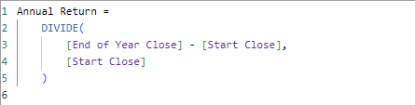

This column calculates the annual return of a stock by taking the difference between the closing price at the end of the year and the starting price, divided by the starting price.

**-Annual Share Change**

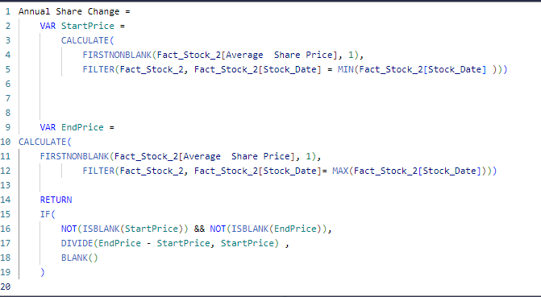

This calculates the annual share change in the share price by comparing the starting and ending average share prices for a given year.

**-Annual Volatility (index)**



This formula calculates the annualized volatility by using the standard deviation of daily returns and multiplying it by the square root of 252 (number of trading days in a year). It gives a measure of how much the price fluctuates annually.

**-Average Gold Price**



This calculated column computes the average gold price over the entire period of data available.

**-Average Interest Rate**

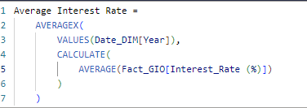

This formula calculates the average interest rate for each year, using the AVERAGEX function to iterate over each year and calculate the average interest rate.

**-Average Oil Price**



This calculates the average oil price across the dataset.

**-Daily Return (for index)**

This formula calculates the daily return of the S&P 500 Index by comparing the current day's closing price with the previous day's closing price.

**-End of Year Close(for index)**

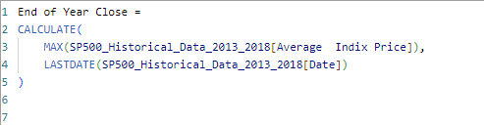

This returns the closing price of the index on the last trading day of the year.

**-Highest Gold Price**



This calculated column finds the highest gold price in the dataset.

**-Highest Interest Rate**



This formula retrieves the highest interest rate recorded in the dataset.

**-Highest Oil Price**



This column calculates the highest oil price over the dataset’s timeframe.

**-Kurtosis Gold Price**

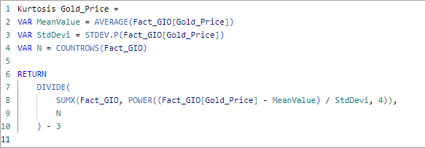

This column calculates the kurtosis of the gold price distribution to determine how extreme the outliers are in the dataset.

**-Kurtosis Index**

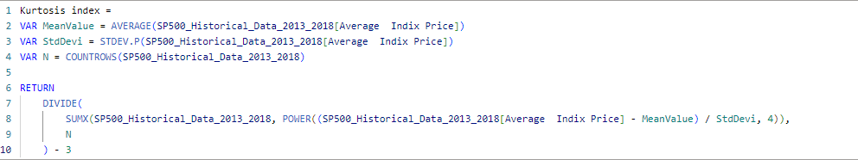

This formula calculates the kurtosis of the S&P 500 Index prices, which is a measure of the tails of the distribution. Positive kurtosis indicates heavy tails (leptokurtic), while negative kurtosis indicates lighter tails (platykurtic). Subtracting 3 converts the calculation to "excess kurtosis," which compares the shape to a normal distribution.

**-Kurtosis Oil Price**

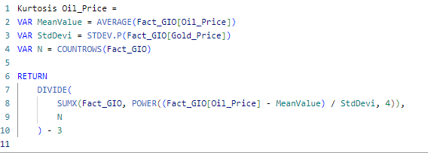

This formula calculates the kurtosis for oil prices, helping to identify how much the distribution differs from a normal distribution, especially in terms of extreme values or outliers.

**-Price/Earning Ratio (P/E Ratio)**

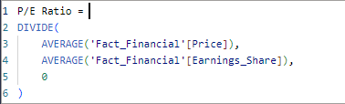

This formula calculates the Price-to-Earnings (P/E) Ratio by dividing the average price by the average earnings per share (EPS). It measures how much investors are willing to pay for each dollar of earnings.

**-Previous Year Close(for index)**

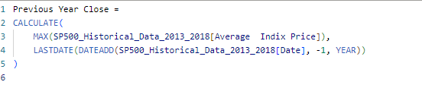

This formula retrieves the closing price of the index at the end of the previous year by calculating the maximum closing price on the last date of the previous year.

**-Resistance Level Per Year For Share**

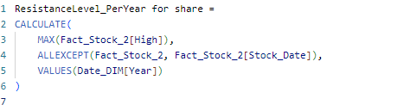

This calculates the resistance level for individual shares, i.e., the highest price the stock has reached within a specific year.

**-Start Close(for index)**

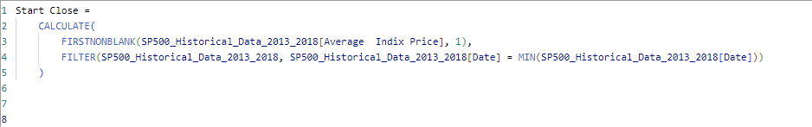

This formula calculates the starting closing price for the index, which is the first available closing price within the data.

**- Support Level Per Year For Share**

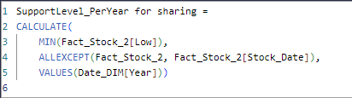

This formula calculates the support level for individual shares, i.e., the lowest price the stock has reached within a specific year.

**-Total Close(for index)**



These measures calculate the total sum of the closing prices for the SP500 index over the selected period.

**-Total Open (for index)**



These measures calculate the total sum of the opening prices for the SP500 index over the selected period.

**-Volume Growth Rate For Index**

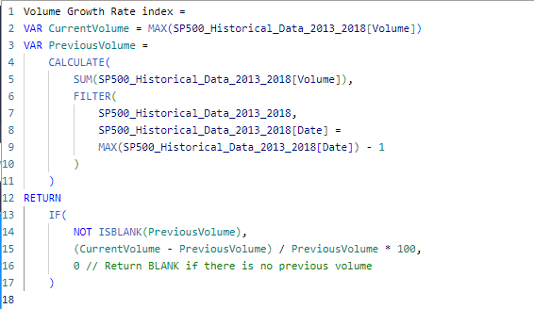

This formula calculates the volume growth rate for the SP500 index by comparing the current volume to the previous volume and expressing the change as a percentage.

**-Year Over Year Gold Price Change**

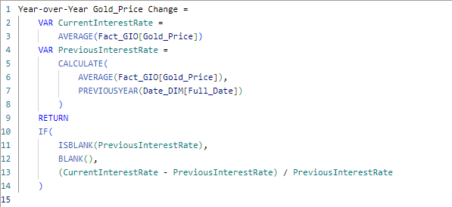

This formula calculates the year-over-year change in the average gold price, comparing the current year's average to the previous year's average.

**- Year Over Year Share Change**

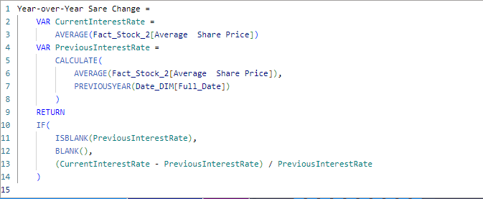

This calculates the year-over-year percentage change in the average share price, comparing the current year's value to the previous year's value.

**- Year Over Year Interest Rate Change**

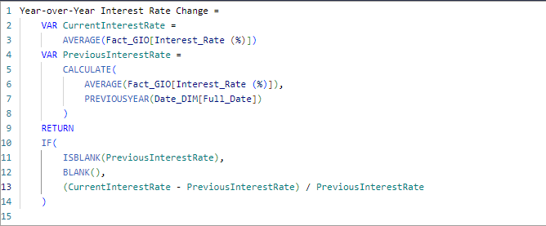

This formula calculates the percentage change in interest rates from one year to the next, helping to identify trends in interest rate fluctuations over time.

**- Year Over Year Oil Price Change**

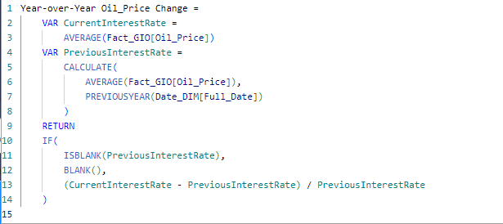

This formula calculates the year-over-year change in oil prices, comparing the average oil price this year to the previous year and showing the percentage changes .

**Reports**

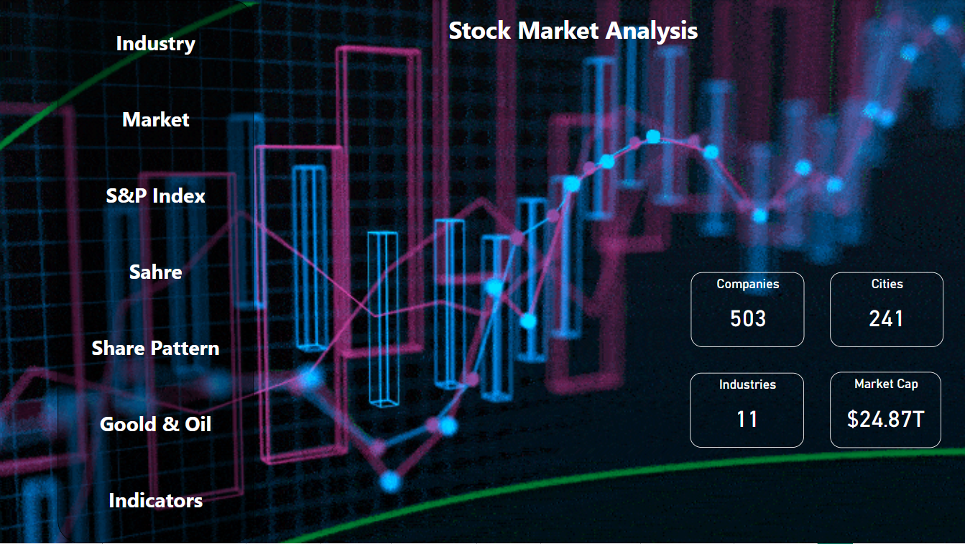**Stock Market Analysis (opening report)**

This report is the opening one which has the page navigator to all reports and some cards which describe some general information about the data like the total companies ,total industries ,cities and the total market cap .

**Industries**

Industries report provides a comprehensive view of market performance across various industries and sub-industries. It allows users to analyze company performance, volume of trading, and annual changes in stock prices, facilitating informed investment decisions.

**1. Industry Selection**

- Dropdown Menu: Users can select specific industries to focus on, such as "Communication Services" or "Consumer Discretionary." This feature allows for tailored analysis based on user interests.

**2. Annual Change Symbol**

- Bar Chart: This component displays the annual percentage change in stock prices for selected companies within the chosen industry. Each bar represents a different company, with the height indicating the percentage change.

**-What we catch:**

- Positive values indicate growth in stock prices over the past year, while negative values signify declines.

- This visualization helps investors identify top performers and underperformers in the market.

**-Reason:**

In **2017 Tax Reform in the U.S.** - New corporate tax cuts boosted earnings and stock prices, leading to significant annual changes for many companies.

**3. Company & Volume by Sub-Industry**

- Bar Chart: This chart shows the number of securities and the volume of trade for each sub-industry within the selected industry.

-**What we catch:**

- The blue bars represent the count of securities, while the yellow line indicates the volume of trading.

- This dual representation allows users to assess which sub-industries are most active and which companies are driving volume, helping to identify trends and potential investment opportunities.

**-Reason:**

In **2015** **Decline in Energy Prices** - Falling oil prices led to reduced trading volume in the energy sub-industry, impacting overall market dynamics.

**4. Low & High**

- Bar Chart: This chart illustrates the average low and high prices of stocks within the selected industry or sub-industry.

**-What we catch:**

- The blue bars indicate the average low prices, while the orange bars represent the average high prices.

- This data is critical for understanding price ranges and volatility, aiding in risk assessment for potential investments.

**-Reason:**

In **2016 Post-Brexit Volatility** - Sharp declines and recoveries in stock prices resulted in wider ranges between average lows and highs.

**5. Company & Volume by Industry**

- Bar Chart: Like the sub-industry chart, this component summarizes the count of securities and the volume of trades across the entire industry.

**-What we catch:**

- Users can quickly gauge overall market activity and identify industries with significant trading volume.

- The combination of securities count and trading volume provides a holistic view of market dynamics.

**-Reason:**

In **2017** **Tax Cuts and Market Rally** - Significant increases in trading volume across most industries due to positive market sentiment.

**Market:**

The Market report offers a detailed analysis of market capitalization for various companies, providing insights into their size and financial health. This dashboard allows users to evaluate the market cap distribution among different symbols and understand the outstanding shares for major companies.

**1. Market Capitalization Overview**

- Bar Chart: This component displays the market capitalization of selected companies (symbols). Each bar represents the total market cap, providing a visual comparison of company sizes.

**-What we catch:**

- Users can quickly identify the largest companies in the market.

- The chart helps investors assess the weight of different companies in their portfolios and the overall market.

**-Reasons:**

* In **2017 Tech Sector Boom** - The technology sector experienced substantial growth, with major companies like Apple, Amazon, and Google reaching record market capitalizations. This surge was driven by increased consumer adoption of tech products and services.

**2. Outstanding Shares for Top 5 Symbols**

- Chart/Table: This section presents the total number of outstanding shares for the top five companies by market capitalization.

**-What we catch:**

- Provides crucial information on liquidity and stock availability.

- Higher outstanding shares can indicate greater liquidity, but may also dilute earnings per share (EPS).

- This data is essential for understanding the supply side of the stock market.

**-Reasons:**

* In **2018 Stock Buybacks** - Many companies, including major players like Apple and Microsoft, initiated significant stock buyback programs following tax reforms. This reduced the number of outstanding shares, potentially increasing earnings per share and boosting stock prices.

**3. Symbols by Company Size**

- Pie Charts: This section categorizes symbols based on their market capitalization, divided into different size categories: Large-Cap, Mid-Cap, and Micro-Cap.

**-What we catch:**

- Users can visualize the distribution of companies within these categories.

- Understanding the segmentation helps in assessing risk and growth potential, as large-cap companies tend to be more stable, while smaller companies may offer higher growth potential but with increased risk.

**-Reasons:**

* In **2016** **Market Volatility** - The market experienced fluctuations due to global economic concerns and geopolitical events, impacting the categorization of companies by size. This volatility led to shifts, with some companies moving between mid-cap and large-cap classifications.

**S&P 500**

These charts collectively highlight how economic policies, political events, and corporate earnings have influenced the stock market index between 2013 and 2018. They provide a comprehensive view of market trends, volume fluctuations, and risk (via volatility and kurtosis), helping investors make informed decisions.

**1. High-Low-Volume Distribution**

This chart shows the maximum and minimum values for the index price, along with the total volume for each quarter from 2013 to 2018. The bars represent the high and low values of the index, while the line graph shows the sum of the volume traded.

**2. Volume Index**

This chart presents the monthly volume traded from 2013 to early 2018, showing the distribution of trading activity throughout the year.

**3. High & Low Index**

This chart visualizes the maximum and minimum values of the index over the years, from 2013 to 2018.

**4. Volatility & Return**

This chart compares the annual volatility and the annual return from 2013 to 2018. The volatility is shown as a blue area graph, while the return is shown as a line graph.

**5. Kurtosis Index (Bottom Left)**

* This chart shows the kurtosis of the index distribution over time, providing insight into the "tailedness" of the data. Higher kurtosis values indicate more extreme outcomes, while lower values indicate a more normal distribution.

**6. Annual Change Close Percentage (Bottom Right)**

This chart highlights the percentage change in the closing price of the index from year to year, from 2014 to 2018. It tracks increases and decreases in the index value.

**7. Index Overview**

* **Purpose:** The summary numbers provide key figures for the index, such as the average index price, average volume, minimum low, and maximum high over the years 2013-2018.

**Share:**

This section of the dashboard presents a detailed analysis of share prices and performance metrics for various companies within a selected industry. The visualizations provide insights into earnings per share (EPS), price performance, annual share changes, and net profit, helping users to evaluate investment opportunities and make informed decisions.

**1. Earnings By Share For Symbol:**

* This component displays the earnings per share (EPS) for selected companies, represented by individual symbols.

**- What We Catch:**

* Each ticker symbol (e.g., AMZN for Amazon, JNU for Juniper Networks) is listed with its corresponding EPS value.

- This data is crucial for investors assessing profitability and comparing performance across companies.

- The "Fairly Valued" indication suggests that the current share price is aligned with the company's earnings performance.

**Reason:**

* In **2017** Strong rally in stock prices driven by corporate tax reforms led to improved EPS for many companies.

**2. Price & Earnings By Share:**

* This chart shows the relationship between share price and earnings per share for selected companies.

**- What We Catch:**

- The chart typically includes a line representing the average price alongside bars for EPS.

- Users can quickly identify which companies have high share prices relative to their earnings, indicating potential overvaluation or undervaluation.

- This analysis helps investors gauge market sentiment and make strategic investment choices.

**Reason:**

* In **2016** Market turbulence post-Brexit affected share prices across multiple sectors.

**3. Price Performance For 5 Symbols:**

A line chart illustrating the price performance of five selected stocks over a defined period.

**- What We Catch:**

- This visualization allows users to compare the price trends of these stocks, identifying patterns such as growth, decline, or volatility.

- Users can analyze the overall trend and performance relative to market conditions.

**Reason:**

* In **2016** Brexit-related volatility resulted in significant price fluctuations for many stocks.

**4. Annual Share Change For Top 5 Symbols:**

* This component showcases the annual share price change for the top five companies represented in the dashboard.

**- What We Catch:**

- The graph typically displays percentage changes year over year, allowing for quick assessments of stock volatility and performance.

- This data is valuable for understanding long-term trends and making future projections.

**Reason:**

* In **2017** Strong annual share changes driven by tax reform and economic growth.

**5. Sum of Net Profit:**

* This metric summarizes the total net profit for the selected companies.

**- What We Catch:**

- A comprehensive view of net profit helps investors evaluate the overall financial health of the companies listed.

- Tracking net profit trends can indicate a company's ability to generate income and manage expenses effectively.

**Reason:**

* In **2017** Tax cuts and economic growth led to significant increases in net profits across various sectors.

**Share Pattern:**

This section of dashboard analyzes various financial metrics for several companies, including price-to-earnings ratios, share price performance, earnings, and net profit. The visualization is structured to highlight key performance indicators, company comparisons, and financial health across the top companies in the market.

**PE Category (Price to Earnings Ratio Category):**

* This segment categorizes stocks as **Fairly Valued**, **Over Valued**, or **Under Valued** based on their P/E ratios.
  + **Fairly Valued**: Stocks within an acceptable P/E range, indicating that their prices reflect their earnings.
  + **Over Valued**: Stocks with higher-than-normal P/E ratios, suggesting they are more expensive relative to their earnings.
  + **Under Valued**: Stocks with lower-than-average P/E ratios, potentially indicating that they are undervalued relative to their earnings.

**Price & Earnings By Share :**

* **Event**:
  + **AMZN (Amazon)**, **GOOG (Google)**, and **EQIX** maintain a balance between high prices and earnings. This is often driven by continuous innovation and strategic market expansions.
  + **WMT (Walmart)** and **BA (Boeing)** display moderate prices and earnings. While these companies maintain a strong market presence, they haven't experienced the explosive growth seen in tech companies like Amazon and Google.
* **Insights**:
  + The performance of tech companies in 2018 is a reflection of advancements in AI, cloud, and consumer services, which drove up both prices and earnings.
  + **BA**'s earnings might be impacted by geopolitical issues, as its revenue is tied to defense contracts and global trade.

**Price Performance For 5 Symbols :**

* **Event**:
  + **SNI**, **VFC**, and **COL** have seen price declines. This might be driven by market pressures, underperforming quarterly earnings, or sector-wide challenges.
  + **COL** (Rockwell Collins) was acquired by United Technologies in 2018, which likely caused some of the performance changes.
* **Insights**: Price declines for companies like **VFC** and **SNI** may be influenced by competitive pressures in the retail and consumer goods sectors.

**Low & High 52 Week :**

* **Event**:
  + **RRC (Range Resources)** and **GE (General Electric)** show the largest volatility in their 52-week highs and lows. These companies, particularly **GE**, have faced market volatility due to management changes and restructuring efforts.
  + **AMD (Advanced Micro Devices)** and **NVDA (Nvidia)** show more stability, likely reflecting the consistent growth in the semiconductor industry.
* **Insights**:
  + **RRC**’s volatility might be attributed to fluctuations in energy prices, while **GE**’s struggles were tied to internal challenges and industrial market conditions.
  + **AMD**’s and **NVDA**'s relatively smaller spread reflects their rising position in the high-demand market for GPUs and processors.

**Annual Share Change For Top 5 Symbols :**

* **Event**:
  + **NFLX (Netflix)** experienced significant growth in 2018 due to its expansion into international markets, continuous content investment, and subscriber growth.
  + **NVDA (Nvidia)** and **ALGN** also show strong upward trends due to the increasing demand for GPUs (Nvidia) and orthodontics products (Align Technology).
* **Insights**: The spikes in these symbols’ share prices during 2018 were driven by strategic expansions and innovative products, helping them outperform in the stock market.

**Sum of Net Profit (Bar Chart):**

* **Event**:
  + **AAPL (Apple)** and **GOOG (Google)** are shown with the highest net profits, reflecting their leadership in the tech sector. These companies have diversified their revenue streams, with **AAPL** seeing strong performance from iPhone sales and services, and **GOOG** benefiting from advertising revenue.
  + **COG (Cabot Oil & Gas)** has also shown strong profits due to the rising prices of natural gas and oil, despite some volatility.
* **Insights**: **AAPL** and **GOOG**'s high net profits reflect their successful monetization of ecosystems and technologies. The energy sector, represented by **COG**, has benefited from favorable commodity prices during this period.

**Gold and Oil:**

This report dives deeper into the risk and volatility associated with Gold and Oil prices by examining their kurtosis. It also shows the average Oil-to-Gold ratio, which reflects the relative pricing of the two commodities over time. Scatter plots are used to compare interest rates with Gold and Oil prices, providing insights into how these commodities behave under different interest rate conditions.

**Average Oil to Gold Ratio:**

* This chart shows the oil-to-gold price ratio over time. The ratio spiked around 2016 when oil prices dropped significantly, highlighting the disparity between the two commodities.

**What we Catch**: The ratio spiked in 2014 and reached a high in 2016.

**Reason**: In 2014, the oil-to-gold ratio increased because oil prices dropped significantly, while gold prices remained relatively stable. The 2016 peak was due to the oil price recovery after OPEC’s production cuts, which stabilized oil prices relative to gold.

**Oil Price & Interest Rate Scatter Plot:**

* A scatter plot shows the relationship between oil prices and interest rates. While the trend is generally positive, indicating that higher interest rates align with higher oil prices, there are instances where this relationship is less consistent.

**Gold Price & Interest Rate Scatter Plot:**

* A scatter plot similar to the oil one, but for Gold prices. The relationship here shows less clear correlation as Gold prices are more influenced by global economic uncertainty and inflation than by interest rates directly.

**Highest Interest Rate:**

* This chart highlights the periods where interest rates reached their peaks, especially in 2017 and 2018, when the Federal Reserve was increasing interest rates.

**Risk of Gold Price & Oil Price (Kurtosis):**

* This chart provides a measure of risk (kurtosis) for both Gold and Oil prices. A higher kurtosis for Oil indicates more frequent large fluctuations (i.e., more risk), while Gold shows a more stable pattern with a lower kurtosis value.

**What we Catch**: Oil prices showed higher risk (volatility) than Gold, especially in 2015.

**Reason** : The kurtosis of oil prices increased in 2015 due to the sharp drop in oil prices that year. This indicates that oil prices were more prone to extreme movements compared to Gold, which is generally more stable.

**Indicators:**

This dashboard explores the relationship between Gold, Oil, and Interest Rates over time from 2013 to 2018. It highlights key trends, such as how changes in interest rates influenced both Gold and Oil prices. The dashboard breaks down year-over-year changes for these commodities and provides insights into how price volatility for Oil was much higher than for Gold.

**Gold Price & Interest Rate:**

* This chart shows the historical trend of Gold prices against Interest Rates from 2013 to 2018. It highlights how Gold prices increased while interest rates remained low until 2016. As interest rates increased after 2017, Gold prices saw a more gradual increase.

• **What we Catch**: The relationship between **Gold Prices** and **Interest Rates** is complex. Although rising rates often lead to lower Gold prices, this chart shows that external factors.

**Oil Price & Interest Rate:**

* This chart reveals a comparison for Oil prices. It shows that oil prices decreased significantly in 2015 (due to oversupply and other global events) despite low interest rates. Later, when interest rates started increasing, oil prices also started to recover.

• **What We Catch** : In 2015, Oil prices fell sharply, while interest rates remained low.

• **Reason** : The major drop in oil prices in 2015 (around -47%) was due to a supply glut, driven by the boom in U.S. shale oil production and OPEC’s decision not to cut production. The global oversupply led to lower oil prices despite stable interest rates.

**Interest Rate & Year-over-Year Change:**

* This chart indicates the fluctuation in Interest Rates and their year-over-year changes. It shows sharp increases in interest rates in 2017 and 2018, illustrating monetary policy adjustments aimed at curbing inflation.

**What we catch**: In 2017, there is a sharp spike in interest rates, followed by a decline in 2018.

**Reason**: This reflects the Federal Reserve’s decision to increase interest rates multiple times in 2017 to control inflation as the U.S. economy continued to grow. By the end of 2018, the Fed started to raises in 2016 and started to slow down the rate hikes due to concerns about economic growth.

**Oil Price Year-over-Year Change:**

* Oil prices saw the most significant year-over-year drop in 2015 (a 47% drop), but a significant recovery began in 2016. The chart reflects how oil prices can be highly volatile, often influenced by geopolitical factors.

**What we Catch**: Oil prices dropped by 47% in 2015 and rebounded in 2016.

**Reason**: The 2015 oil price collapse was caused by oversupply and weakened demand, particularly from emerging markets like China. The subsequent recovery in 2016 was helped by OPEC’s agreement to cut production and balance the market.

**Gold Price Year-over-Year Change:**

* The Gold price fluctuations are less volatile than Oil. The chart shows minor changes in the early years, but a notable 8% increase occurred in 2016 and 9% in 2018, which could be tied to global uncertainty and rising interest rates.

**Significant Change**: There was a notable drop in Gold prices (-8%) in 2015.

**Reason for Change**: The Gold price drop in 2015 was driven by rising expectations of an interest rate hike in the U.S. As interest rates rise, the opportunity cost of holding Gold (a non-interest-bearing asset) increases, leading to lower demand.

**General Recommendations**

* A graph with a red arrow

  Description automatically generated The stock market can be volatile in the short term. Focus on long-term growth rather than short-term fluctuations.
* A newspaper with text on it

  Description automatically generated Keep up with economic news, earnings reports, and changes in the market that could affect the S&P 500.
* A colorful pie chart with a black background

  Description automatically generated Consider investing in S&P 500 index funds, which typically have lower fees and provide broad market exposure.
* A computer screen with a person's face

  Description automatically generated Spread investments across different sectors to minimize risk. Avoid over-concentration in one area.
* A magnifying glass with a black background

  Description automatically generated Stay informed about economic indicators, market sentiment, and geopolitical events that can impact stock prices.
* A blue and green planet

  Description automatically generated Monitor global economic conditions, interest rates, and geopolitical tensions that can affect gold prices.
* A gold bars stacked on top of each other

  Description automatically generated Gold often serves as a long-term store of value. Avoid short-term speculation unless you are experienced.
* A blue and white shield with a green tick

  Description automatically generated If investing in physical gold, ensure proper storage and consider insurance for security.
* A barrel with a yellow circle and a yellow circle on it

  Description automatically generated Oil prices are influenced by global supply and demand dynamics, OPEC decisions, and geopolitical events.
* A cartoon of a factory

  Description automatically generated Keep an eye on indicators like U.S. inventory levels, production rates, and economic growth in major consuming countries.
* A green circle with a black dollar sign

  Description automatically generated Rising interest rates can lead to lower stock prices as borrowing costs increase and consumer spending slows.